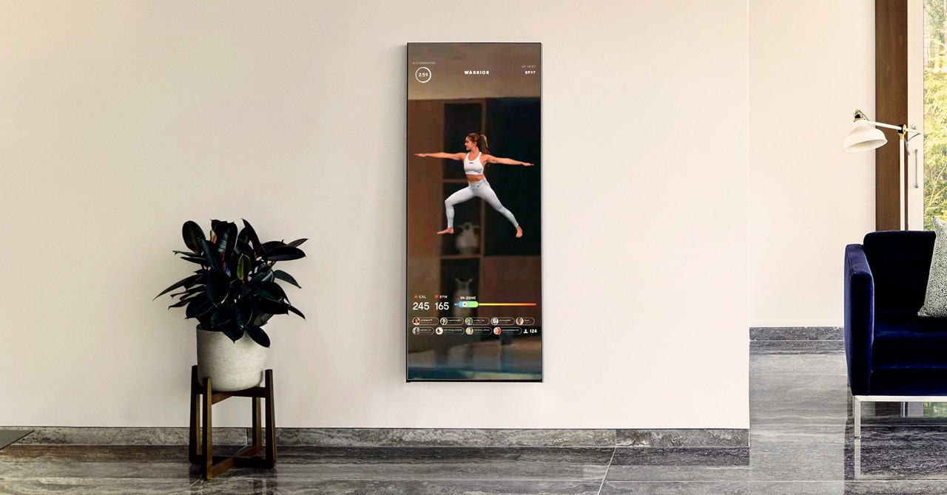

With people becoming more and more conscious about smarter ways to work out, the intelligent workout equipment grows to be a favorite for the sweat-loving groups. Either it’s wearable apparel like Apple Watch, advanced traditional device such as bike or treadmills, or today’s protagonist – innovative all-in-one fitness mirror, the more-than-traditional home gym gears rocket even more with COVID storms. Without further ado, let’s dive in this week’s product – The Mirror.

Notes:

* The superscript indicates which source the information comes from

Specs:

* **User:**

|  |  |
| --- | --- |
| Customer persona | Young workout-loving, wealthy people seeking for advanced home exercise equipment and personal training |
| Size of user base | “Tens of Thousands” 2, 50,000 – 1.5M (estimated based on yearly revenue) |
| Geography | US |
| Demography | Younger people (better around technology) |
| User acquisition | Acquire large number of users during COVID; Celebrity social media marketing |
| User retention | If the mirror does not break, with continued interest in workout |
| Feedback | Beautiful design, classes of all types and lengths, easy-to-use app (+); Costly, software update issues, Wi-Fi Issues(-) 10 |

* **Product:**

|  |  |
| --- | --- |
| Definition | Tech-enabled mirror with huge screen, a camera, and speakers |
| Pain point solved | Lack of space (thin multi-functional mirror); Lack of All-in-one home gym; unwillingness to go to gym for personal training |
| Price | $1495 (or $42/month, $0 down, 0% APR),  $39/month (Mirror membership to use its app for classes) |
| TAM (Total Available Market) | “Massive” 9, 34.1%*122.8M*$1495 = $62.6B (assume all the household with annual revenue >$100,000 can be customers 16) |
| Release date | September 2018 2 |
| Platform | Self-developed software (iOS, Android) |
| Update cycle | Not known |
| Components (upstream) | Large piece of glass, LED screen, camera, quad-core processors, speakers*2, Microphone |
| Distribution (downstream) | Online - Official website, Amazon (used to?) 14  In person – Showroom, Lululemon stores 15 |
| Marketing | Celebrity storm |
| Competitor products | Echelon’s Reflect 14 ($1040 for 40’’, $1640 for 50’’, the Mirror is 40’’), Peloton’s smart bike (~$2000) and treads ($2500/$4300), Tonal smart home gym ($3000) |

* **Company:**

|  |  |
| --- | --- |
| Name | Mirror.co |
| Founder | Brynn Putnam (chain of boutique fitness studios owner) |
| Founded | Late 2016 |
| Industry | Exercise equipment |
| Parent company | Lululemon (acquired June 2020 for $500M) |
| Size (Employee) | 19,000 (Lululemon 2020) 4, 125 (mirror 2020) 7 |
| Revenue | $4.09B (Lululemon 2019) 6, $100M (mirror) 5 |
| Profit | $2.62B (Lululemon 2020 Nov) 5, (Mirror not known) |
| Funding | $72M (year to date) 23 |
| Focus area | Workout Clothing and Equipment |
| Product role to company | The only product for the standalone startup within a bigger athletic apparel retailer |

Story:

Brynn Putnam, a graduate from Harvard University with a degree in Russian literature and culture, could not stand having to go to a studio to workout with a baby in her belly. She was newly pregnant, and the trip to the studio is making her miserable. “Mirror was born from personal need”, says Brynn. When her son George was born, in hospital bed, she was reading documents for her first round of funding.

Without any coding experience, Brynn persisted on her vision. As a former NYC ballet dancer and previous entrepreneurial experience in a chain of modern studio, she had the right industry knowledge and enough passion to realize her ideas. Luckily, her husband has development experience and gave her a hand during the blueprinting phase of Mirror. After 1.5 years of finding funding and assembling team, the Mirror was released in September 2018.

The Mirror became a hit after Alicia Keys posted a video on Instagram in which her family surprised her with the new Mirror product. In the video, she was extremely excited, jumping around and screaming; one thing led to another, a huge part of the Hollywood and American stardom does some form of marketing for the Mirror. Is it paid? The answer is very likely yes, as Brynn Putnam said she and her team “did very strategic early celebrity placements” 7.

The new hit drew Lululemon’s attention. In June 2020, the athletic apparel company announced the acquisition of Mirror for $500 million. From a business perspective, this move showed the determination of Lululemon to solidify its image in high-end workout market and establish some footprint in smart exercise device, other than just clothing, sneakers, and small gadgets.

Let’s talk about the product itself.

First, the Mirror is definitely a beautiful product. There is no denying in that. I decided to write about the Mirror as the first volume of my product weekly column was majorly because it triggered my buyer’s impulse as soon as I laid my eyes on that sleek design. The product is thin (1.7 inches), can be mounted on the wall, and could be used as a dope modern décor in any house. This is the major selling point for Mirror – it all of a sudden makes your workout upscale. Comparing with its counterparts in other companies (Peloton, Tonal, Echelon), the Mirror is a clear winner when it comes to the look.

Second, a good look isn’t enough. How’s the function of the product? Does it really serve as your personal trainer? The answer is leaning towards yes. The key thing about the product is that it comes with an app that includes all the training courses. I have not tried the app but according to multiple sources, the training courses are “across all types, intensities and lengths”, which is good for a product that aims at everyone who wants to work out at home. With all the options and a 40’’ 1080p screen that shows your heart rate (monitored by the heart monitor that comes with the mirror), calories burned, you would be sweating with the right guidance. The key problem-solving point about Mirror is that you can see the correct form of the exercise and replicate it exactly.

In the app, you store your personal information for more accurate workout, control volumes from the built-in speakers in the Mirror, and stream your own music. However, this app costs $39 a month to subscribe, which combines with the mirror itself, really could not say you too much money from a regular gym subscription.

That leads to our third topic – price. The mirror is definitely pricey, although it is kind of a standard in the smart home gym market. The competitors would only be more expensive, as a matter of fact. However, buying a “mirror” that costs $1495 with $250 installation fee and $39/month after that, it should be considered as an investment in healthy lifestyle, especially for an average income household. However, the product can be used for everyone in the family, and it does come with a 0% APR buying option.

Fourthly, the problems. The software update will go through the company-provided router but will take forever if you connect it to your own Wi-Fi. Sometimes it is backwards – you will have to connect to your network. The buffering problem during a workout is troublesome too, and that happens even to the fastest network available 10. The app lacks a few user-friendly features like going to sleep if not in use – which could awake a sleeping customer as a trainer on the screen suddenly decides shouting encouraging words energetically. These drawbacks do seem like easy and minor fixes for the development team, though, if they have enough technical resources for the maintenance and continuous updates.

All in all, with my research, my opinion on this product is that – It serves its purposes, but the purposes are limited. it seems like a premium nice-to-have, just like Apple Watch, and probably plays a less important role than the watch.

From a user perspective, I firmly believe this product is for medium to advanced workout lover (and impulsive buyers?), since a smart mirror won’t really encourage you to work out every day (people start to slack off using it after three days), and it is even more expensive per use if you only workout once in two weeks.

From a product perspective, the functions are mostly satisfying, and the idea is innovative. It does solve the pain points of people not wanting to commute for workout, lack of space at home, and in need of personal workout guidance whenever convenient. It needs to be updated continuously to provide a better smoothness.

From a market perspective, the smart home gym is a new market with a lot of potential. Exercising is for everyone, and everyone has a home. Trainers can help us to achieve better form, but we can do that ourselves, looking in a mirror. With more products breaking grounds in this industry and the technology ripens, hopefully we can see the prices drive down and the mirror could become the leader in a smart position, just like what it’s intending to do, the iPhone in smart home gym.

As a consumer who exercises with impulses, I would love to have it for less money and low key show my friends during a house tour. And yeah, also work out with it, I guess.

Q&A:

* How is the manufacturing problem solved?
  + BP: “I actually went backwards. I drew a sketch on a napkin and did **a small set of bullets of the things** that I thought were really just crucial to make the product a success. And then I went to **find factories in China that were familiar with digital signage**, working with large pieces of glass, large mirrors, learned about their systems and processes, and then brought it back to the U.S. to **a local manufacturer here on the East Coast** to refine into a prototype. And then **we eventually moved to Mexico when we were ready to scale**.” 7
* When you look at Peloton now and how its stock has completely exploded this year, do you ever think ‘maybe I sold too soon?’
  + BP: “I spend very little time comparing to competitors and much more time focused on our members’ needs and how to meet them.” 7
* The mirror is about $1,500 dollars. How did you go about winning the trust of consumers that would lead them to make such a sizable investment?
  + BP: “When you’re building a new product, you can’t really compete on specs and features like you do with phones or laptops. So, you’re really building a brand, which means that you’re telling stories. And in our case, we spent a lot of time, from the very early days, really imagining the life of our members and figuring out how to craft and tell that story. And then we were fortunate early on to have members fall in love with the product. And then they started to tell our story for us. Once you have that customer flywheel that starts to kick in, your job becomes much easier.” 7
* Who started that conversation with Lululemon? Were you talking to Peloton and other potential acquirers?
  + BP: “I’ve been really fortunate to actually work with Lululemon for my entire fitness career. There was a team of Lululemon educators here in New York who were the very first clients of my studio business, and frankly, in many ways were responsible for helping that business to grow and thrive and to give me confidence as a first-time small business owner. Then we reconnected with Lululemon about a year before the acquisition as an investor; they made a small minority investment in the company. And we began to work together on various projects . . . From there, really, the partnership just grew. Mirror was not for sale. We were not looking for an acquirer. But it’s really your responsibility as a founder to always be weighing your vision, your responsibility to your team and your responsibility to your shareholders. And so, when the opportunity presented itself — before COVID actually — it felt like really just too good an opportunity to pass up.” 7

Sources:

1. <https://www.mirror.co/>
2. <https://www.cnbc.com/2020/06/29/lululemon-to-acquire-at-home-fitness-company-mirror-for-500-million.html>
3. <https://marker.medium.com/mirror-wanted-to-be-the-next-iphone-instead-its-selling-to-lululemon-2dc2ebe65431>
4. <https://www.macrotrends.net/stocks/charts/LULU/lululemon-athletica-inc/number-of-employees>
5. <https://growjo.com/company/MIRROR#:~:text=MIRROR%27s%20estimated%20annual%20revenue%20is%20currently%20%2430M%20per%20year.&text=MIRROR%27s%20total%20funding%20is%20%2474.8M>.
6. <https://www.macrotrends.net/stocks/charts/LULU/lululemon-athletica-inc/revenue>
7. <https://techcrunch.com/2020/11/09/mirror-founder-brynn-putnam-on-life-with-lululemon-and-whether-or-not-she-sold-too-soon/>
8. <https://techcrunch.com/2020/06/29/lululemon-set-to-acquire-home-fitness-startup-mirror-for-500m/>
9. <https://www.bloomberg.com/news/articles/2020-06-30/lululemon-s-first-acquisition-offers-seat-at-home-fitness-table>
10. <https://www.tomsguide.com/us/mirror-home-gym,review-6499.html>
11. <https://www.wsj.com/articles/lululemon-to-buy-at-home-fitness-company-mirror-for-500-million-11593465981#:~:text=It%20launched%20in%20September%202018,million%20in%20sales%20in%202020>
12. <https://www.youtube.com/watch?v=C6qfsQtMxb8>
13. <https://echelonfit.com/pages/reflect-mirrors>
14. <https://www.amazon.com/Mirror-Original-Workout-Fitness-Demand/dp/B08LZVX2D5/ref=sr_1_2?dchild=1&keywords=The+Mirror&qid=1606747316&sr=8-2&tag=syn-yahoo-20&ascsubtag=%5Bartid%7C2140.a.34820637%5Bsrc%7Cyahoo-us>
15. <https://www.mirror.co/showroom>
16. <https://www.statista.com/statistics/203183/percentage-distribution-of-household-income-in-the-us/>
17. <https://www.insider.com/luminaries-brynn-putnam-mirror-lululemon-2020-10>
18. <https://www.productbookshelf.com/2015/08/upstream-and-downstream-product-management/>
19. <https://blog.hubspot.com/marketing/total-addressable-market>
20. <https://www.today.com/tmrw/mirror-s-brynn-putnam-prioritizing-fitness-self-care-t199774>
21. <https://www.nytimes.com/2019/02/08/style/mirror-fitness-method.html>
22. <https://www.fool.com/investing/2020/07/28/3-reasons-lululemons-mirror-acquisition-could-end.aspx>
23. <https://www.nytimes.com/2020/06/29/business/lululemon-buys-mirror.html>